The Primary PE

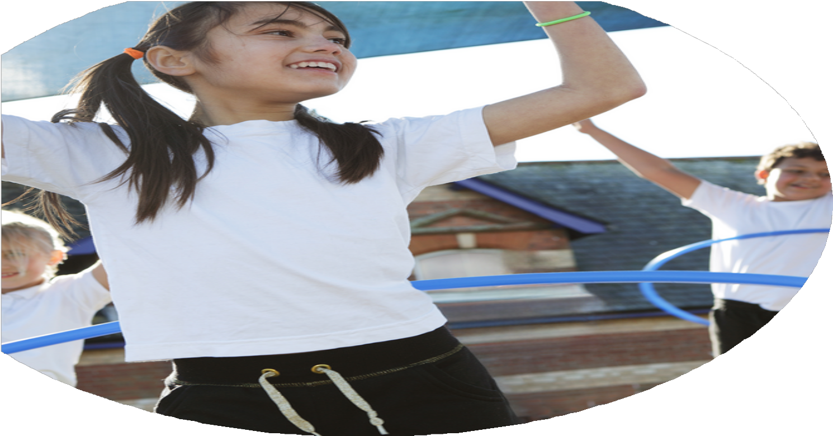

and Sport Premium

Planning, reporting and evaluating website tool

**Commissioned by**

**Created by**

Images courtesy of Youth Sport Trust

**PE Funding Evaluation Form**

 It is intended that this template should be used as preparation for the completion of the statutory digital reporting tool being introduced this academic year. You can upload data (including swimming) from this template onto this platform once it becomes accessible.

 Before you decide how you are going to use the funding for this academic year you should reflect and evaluate the impact of your use of the funding in 2023/24.

 All spending of the funding must conform with the terms outlined in the Conditions of Grant document.  The template is a working document that you can amend/update during the year.

 Based on your evaluation of last year’s funding you should decide what you intend to do this academic year, how you will do it, and what impact you expect it to have.

It is important that the funding is used effectively and based on your school’s needs.

 You must use the funding to make additional and sustainable improvements to the PE and sport in your school.  You must develop and add to the PESSPA activities that your school already offers.

*Summative digital reporting from June 2025 will continue to include swimming and water safety information therefore funding can be used to provide top-up lessons where necessary to ensure pupils meet national curriculum swimming requirements.*

We recommend that you start by reflecting on the impact of current provision and reviewing your previous spend.

What went well?

How do you know?

What didn’t go well?

How do you know?

What are your plans for 2024/25

Intent

How are you going to action and achieve these plans?

Implementation

What impact/intended impact/sustainability are you

expecting?

How will you know? What **evidence** do you have or

expect to have?

What **impact/sustainability** have you seen?

What **evidence** do you have?