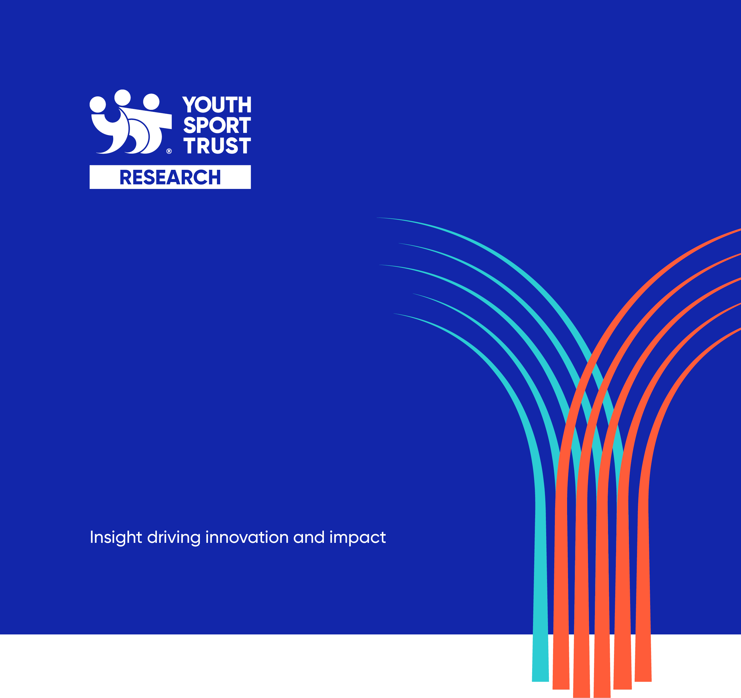

Competition Formats: Research Brief

August 2023

Contents
Introduction 1
About the Project 2
Aims and Objectives of Research 3
Methodology 4
Research Deliverables 4
Key Contacts 4
Research Timescales 4
Budget 5
The Bidding Process 6
Selection Process 6
Timetable 6
Selection Criteria 6
Proposal Requirements 6
Further Information 7
Proposal Submission 7

Introduction
The Youth Sport Trust (YST) is a national children's charity passionate about creating a future where every child enjoys the life-changing benefits that come from play and sport. We are on a mission to pioneer new ways of using sport to improve children’s wellbeing and give them a brighter future.
For more information about our organisation, please visit our website: www.youthsporttrust.org.
The YST is seeking to appoint an external organisation to conduct a consultation exercise with key stakeholders around the National Governing Body format offer for School Games.
This document sets out the research requirements for the work.

About the Project
The Youth Sport Trust are looking for an individual or organisation to conduct a consultation exercise with key stakeholders on the National Governing Body competition formats that are offered as part of the School Games (www.yourschoolgames). Key stakeholders to consult with include, but are not limited to,
- National Governing Bodies (NGBs)
- School Games Organisers (SGOs)
- Schools
- Young People (participants)
There are already two scheduled opportunities where the successful organisation will be able to conduct face to face consultation with NGBs and SGOs.
milestone | Notes | date
National Governing Bodies networking session | - A scheduled session which will provide the successful individual / organisation with the opportunity to conduct face to face consultations with NGB partners | October 2023
School Games Organisers regional conferences | - Four regional conferences, Coventry, London, Leeds and Bristol  - An opportunity for scheduled face to face opportunities to consult with School Games Organisers | November 2023

Aims and Objectives of Research
Aim: To provide recommendations as to what National Governing Body competition formats should look like in the future.
Focus: To consult with key stakeholders to gather their feedback on the current formats and to explore ideas for what any future formats should look like.
The key research questions are outlined in the following table:
research component | key research questions
Process Evaluation | - What works well about the current competition formats?  - What aspects work less well with the current competition formats?  - How do the current competition formats effectively engage young people?  - What types of format are effective at achieving long term engagement from schools and young people?  - How can we improve the current competition formats for the future?
Outcome Evaluation | - What outcomes do the current competition formats have on young people and schools?  - To what extent would the outcomes have been achieved without the current competition formats?  - What different or alternative formats would be more effective?

The Youth Sport Trust aims to put young people at the heart of everything we do and are therefore keen to inform and improve our delivery with insight from young people. Where possible, through the evaluation research tasks, the Youth Sport Trust would welcome insights into the attitudes, motivations and barriers to participation of young people from different demographic groups.

Methodology
The YST would like researchers to propose a methodology that best meets our needs. However, we have outlined a number of key methodological considerations:
- A focus on qualitative research methods. Extra consideration given to research methods which will involve young people with additional support needs, and if these methods are an appropriate measure to capture this data.

- Interactive consultation activities run as part of the already arranged events.

Research Deliverables
The following deliverables are required from this research project:
- Inception note: Following the inception meeting, a full research methodology, with associated timescales and research tools.
- Monthly progress updates: Regular updates on progress and any challenges/ risks in the project.
- Final report / presentation (December 2023): The YST would like one final report that integrates all sources of evidence and provides us with an understanding of the outcomes achieved, and recommendations to inform future delivery (maximum of 20 pages). There will be one single report, but we would value individual sections that look in more detail at each of the component parts. The report should be accompanied by a two-page executive summary and where appropriate, we would welcome the integration of visual diagrams and infographics to help present the findings.

Further guidance on the report content, style and structure will be given to the successful organisation at the inception meeting.

Key Contacts
The research project would be overseen by Clare Warburton, with additional support from Lucy Slavin.

Research Timescales
The timescales for the research project are detailed in the following table.
milestone | Date
Inception Meeting | September 2023
Inception Note | September 2023
Monthly update reports | October, November 2023
Final Report / Presentation | December 2023

Budget
The total budget for the research project is £10,000 (inclusive of expenses and VAT, if applicable).
Successful contractors will be paid against the following terms:
- 10% on a signed contract.
- 90% upon satisfactory completion of the final report.

The Bidding Process

Selection Process
Organisations are required to submit written proposals. Following a review of these, shortlisted organisations will be invited to our Loughborough office for interview on Wednesday 20th September. From this the successful organisation will be selected.

Timetable
milestone | Date
Deadline for proposals | Friday 15th September COP
Interviews | Friday 22th September
Successful organisation notified | Tuesday 26th September
Inception meeting | TBC
Contract signed / first invoice received | End of September 2023

Selection Criteria
Proposals will be judged on the following criteria:
- Methodology, including a good understanding of the research requirements.
- Experience, particularly in relation to evaluation, young people, and inclusion.
- Value for money.

Proposal Requirements
You are invited to submit a written proposal which clearly outlines how you would meet the requirements laid out in this brief. Your proposal should be a maximum of 10 A4 pages (minimum font 11). CV’s, along with any other relevant information can be provided in appendices.
As a minimum, the following elements should be included in your proposal:
- Details of the proposed methodology.
- A brief overview of your organisation’s experience, including examples of similar research projects you have delivered.
- Details of the team who will be working on the research, including their role, previous experience and DBS status if applicable.
- Arrangements for managing the research and quality assuring the deliverables.
- Timetable for delivering the research.
- A breakdown of costs for undertaking the research, including a breakdown of time and costs per activity and per team member.

Further Information
Any questions you have which will help support the development of your proposals and relate to the project being evaluated should be emailed to lucy.slavin@youthsporttrust.org by Friday 8th September.
Responses to queries will be emailed to all interested organisations.

Proposal Submission
Your final proposal should be emailed to lucy.slavin@youthsporttrust.org and received no later than close of play on the Thursday 14th September.

YST RESEARCH

The Youth Sport Trust (YST) is a national children's charity passionate about creating a future where every child enjoys the life-changing benefits that come from play and sport. YST Research offers research, analysis, insight and evaluation services to organisations with an interest in the wider children and young people’s sector. Our research expertise is focussed on improving the wellbeing of children and young people through sport and physical activity.

Our specialisms include:
- Education, PE and school sport
- Community sport / clubs
- Early years settings
- Life skills and employability
- Activism and volunteering
- Health (physical, social and emotional)

For our latest research findings, visit https://www.youthsporttrust.org/news-insight/research

By working with us, you are supporting us to achieve our mission to improve children’s lives and their future.

Youth Sport Trust
SportPark
Loughborough University
3 Oakwood Drive
Loughborough
Leicestershire
LE11 3QF

01509 226600
research@youthsporttrust.org
www.youthsporttrust.org

Registered Charity Number 1086915
Registered Company Number 4180163

The outcome evaluation should focus on assessing whether the short term outcomes were achieved, but the YST would welcome consideration for whether participants are on the right path to achieving the longer term outcomes.

